SYSON# aur SUSP# dono SIO (EC) ke important output signals hote hain. Inka kaam power sequence ke dauran alag-alag power rails ko ON karna hota hai.
SYSON# aur SUSP# dono Enable signals hain, lekin dono ka kaam alag hai.

1. SYSON# (System ON)

Kya hai?
SYSON# = System ON Signal
Ye signal SIO se nikalta hai aur PWM/Buck Controller ko enable karta hai.
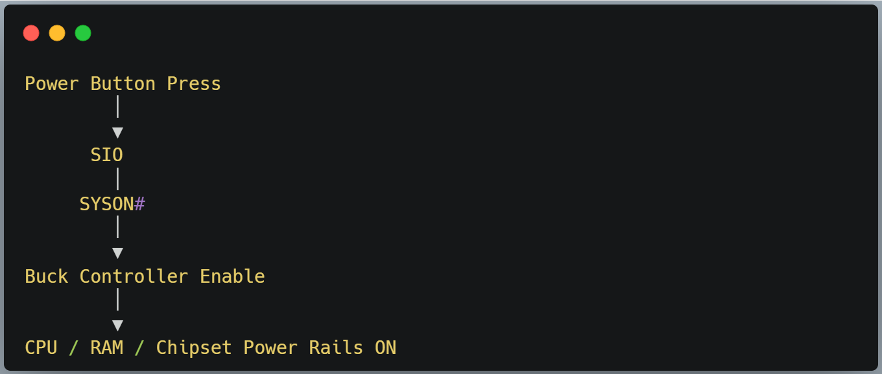

Voltage
State | Voltage
Laptop OFF | 0V
Laptop ON | 3.3V

Kaam
- Main power rails enable karna.
- CPU, RAM aur chipset ki power start karna. (CPU / RAM / PCH Power)

2. SUSP# (Suspend Signal)

Kya hai?
SUSP# = Suspend Signal
Ye bhi SIO ka output hota hai.
Laptop Sleep (S3) aur Resume ke dauran ye signal power regulators ko control karta hai.
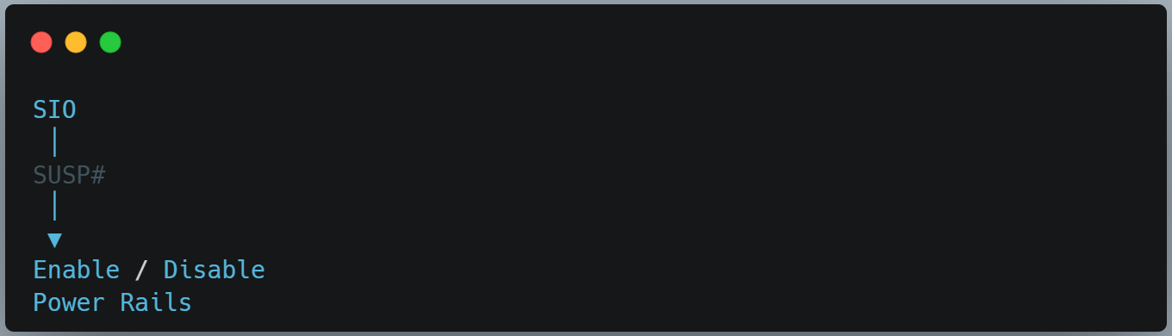

Voltage
State | Voltage
Suspend | 0V
Normal ON | 3.3V

Kaam
- Sleep Mode Control
- Resume Control
- Secondary Power Rails Enable

SYSON# vs SUSP#
Signal | Function
SYSON# | System Power ON
SUSP# | Suspend / Resume Control

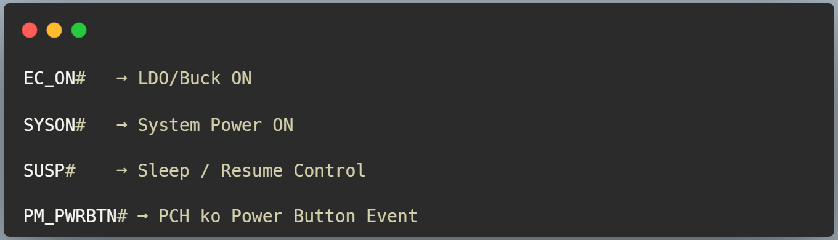
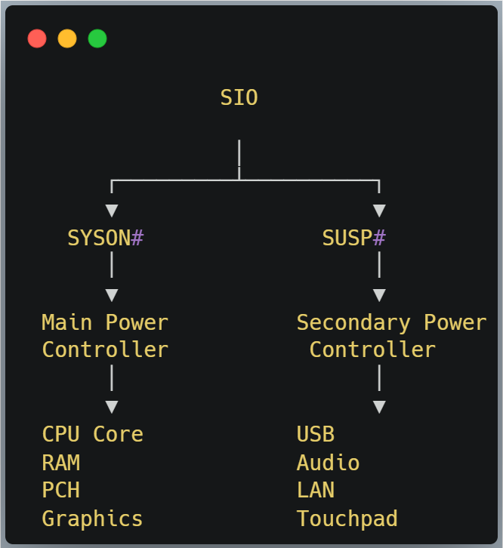

Sleep Mode Me Kya Hota Hai?

Laptop chal raha hai.

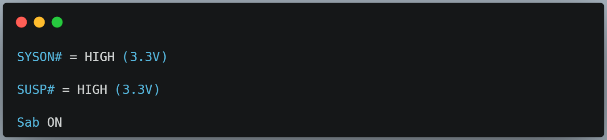

Ab Sleep dabaya.

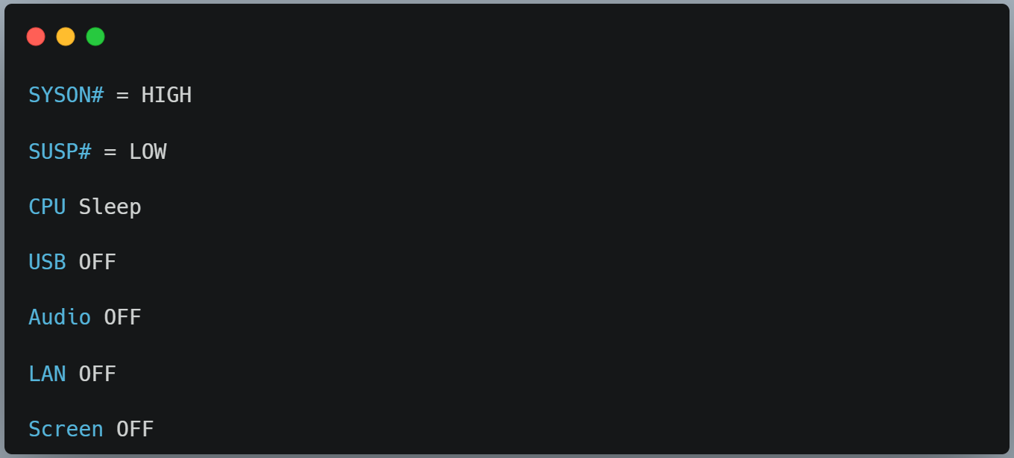
Dhyan do:
👉 Main power abhi bhi ON hai.
Sirf secondary devices band hue hain.

Resume
Mouse hilaya.

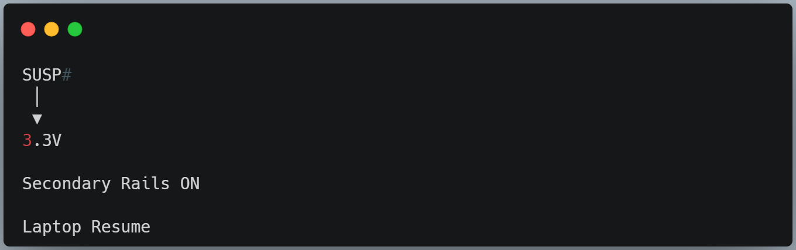

Voltage Table
Laptop State | SYSON# | SUSP#
OFF | 0V | 0V
ON | 3.3V | 3.3V
Sleep | 3.3V | 0V
Resume | 3.3V | 3.3V

Common SIO Output Signals in Different ODMs
Function | Compal | Quanta | Wistron | Inventec | LCFC (Lenovo)
Main System ON | SYSON# | SUS_ON | MAINON | SYS_ON | EC_ON / S5_ENABLE#
Power Enable | EC_ON# | EC_ON | EC_ON | EC_ON | EC_ON
Suspend Control | SUSP# | SUSC# / SUS_ON | SUSP# | SUSP# | SUS_ON / SUSP#
Power Button to PCH | PM_PWRBTN# | PM_PWRBTN# | PM_PWRBTN# | PM_PWRBTN# | PM_PWRBTN#
Resume Reset | RSMRST# | RSMRST# | RSMRST# | RSMRST# | RSMRST#

